Greensheets versioning

## **Goals:**

* Follow up on revised awards (Some clarifications are needed)
* On conceptual level discuss greensheets versioning and select reconciliation method.

**Clarifications for revised awards discussion:**

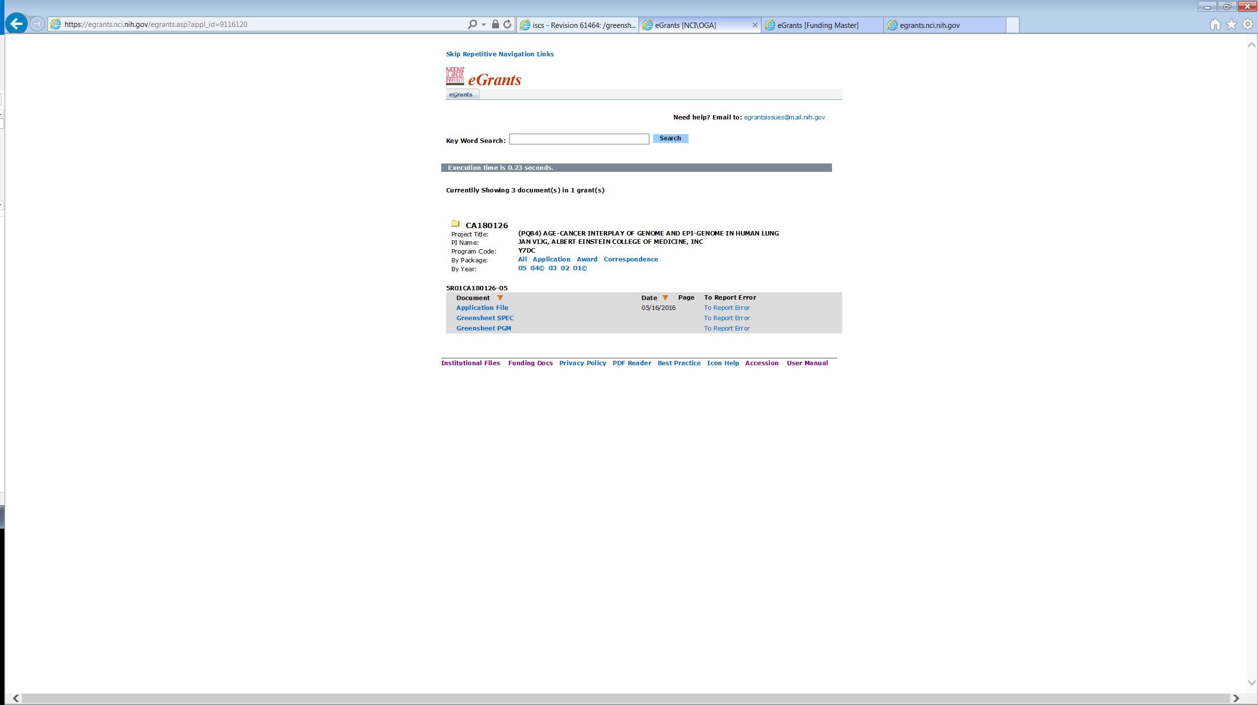

1. Currently majority of the users navigate to a greensheet via eGRANTS. If we will provide “G” icon in GPMATS for AWARD greensheets, there is a possibility that two users will simultaneously open the same greensheets via GPMATS and via eGrants and override each other. Should we prevent this situation or is it OK?
   1. Example of prevention:

**Situation:**

Two specialists opened the same form simultaneously. First person made changes, added attachments and Saved. Second person is attempting to Save later. On Save, the system will display:

**Error:**

While you were working on this greensheet, <First person name> modified the data on <date/time>. Your changes cannot be saved. Please close this greensheet and start again.

* 1. If we need to prevent it, should we use the same approach for specialist navigating via Workbench?

1. Please clarify CBIIT understanding of the requirement that “*revisions greensheets (forms) must be part of official document file*”

That means:

1. eGrants will provide a link to revision greensheet next to award greensheets link.
2. OGA will provide requirements to eGrants dev team about the rules when this link should be displayed. CBIIT task will be to test integration point; coordination is needed between CBIIT and eGrants dev teams.
3. Question: should **revision** greensheet will be editable accessing via eGrants (award greensheets are editable)? Options:

|  |  |
| --- | --- |
| **Option** | **Requirement** |
| Editable | Same rules for displaying the link in eGrants as for displaying “G” icon in GPMATS (as soon as revision action is created; revision action is not in Cancelled status)  Complication: two users can simultaneously open the same revision greensheet via eGrants and via GPMATS, see #1 |
| Read-only | Rules will be different for AWARD and REVISION greensheets (inconsistency) |

1. Since the users of YourGrants and Notification systems are program staff, there is no need to modify these systems:
   * There is a search by GS status in these systems => not affected, keep search for AWARD gs statuses only
   * Keep displaying AWARD gs only according to existing rules
   * No need to modify Details report => keep displaying statuses for AWARD gs only

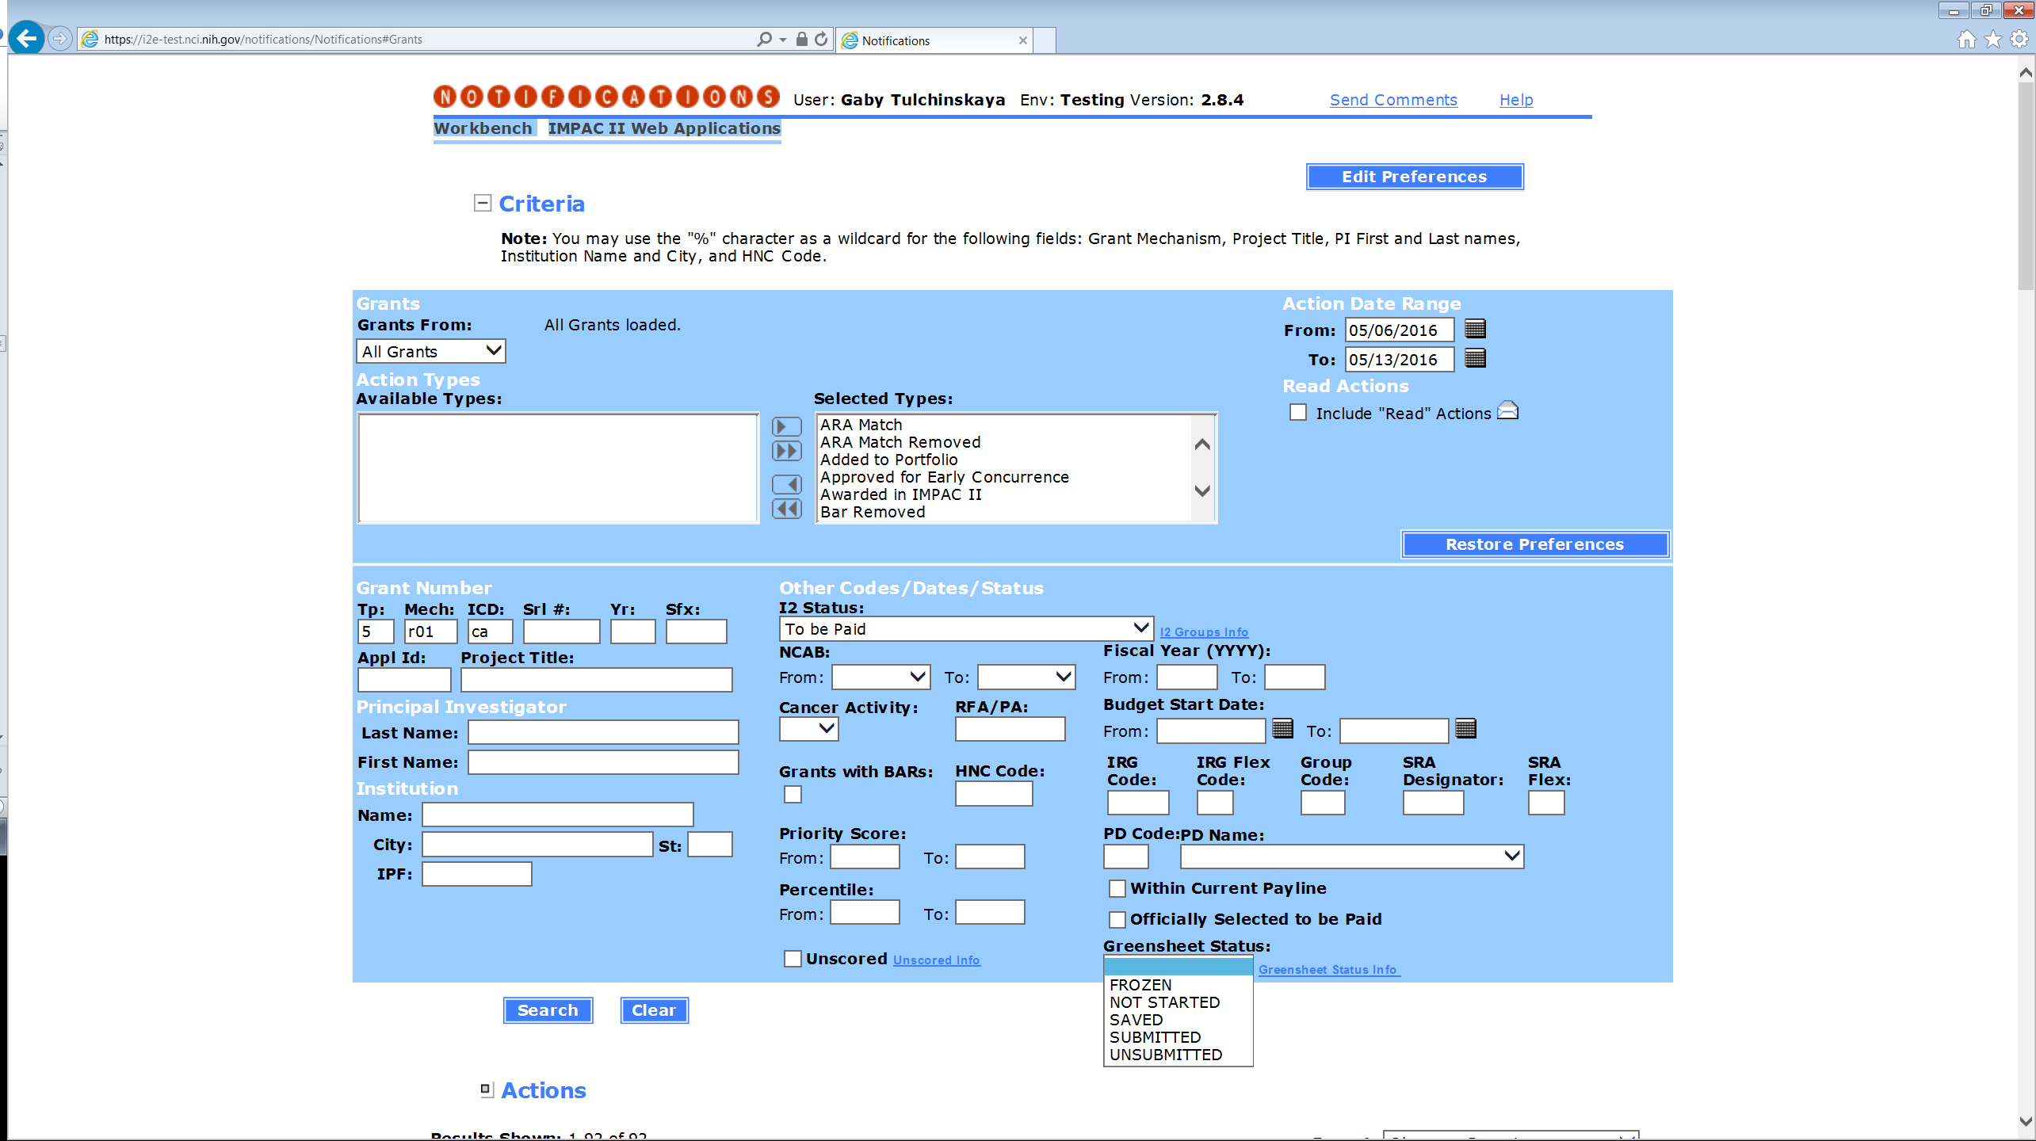

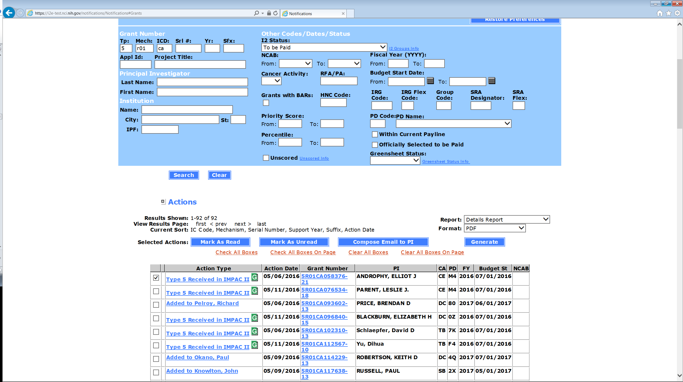

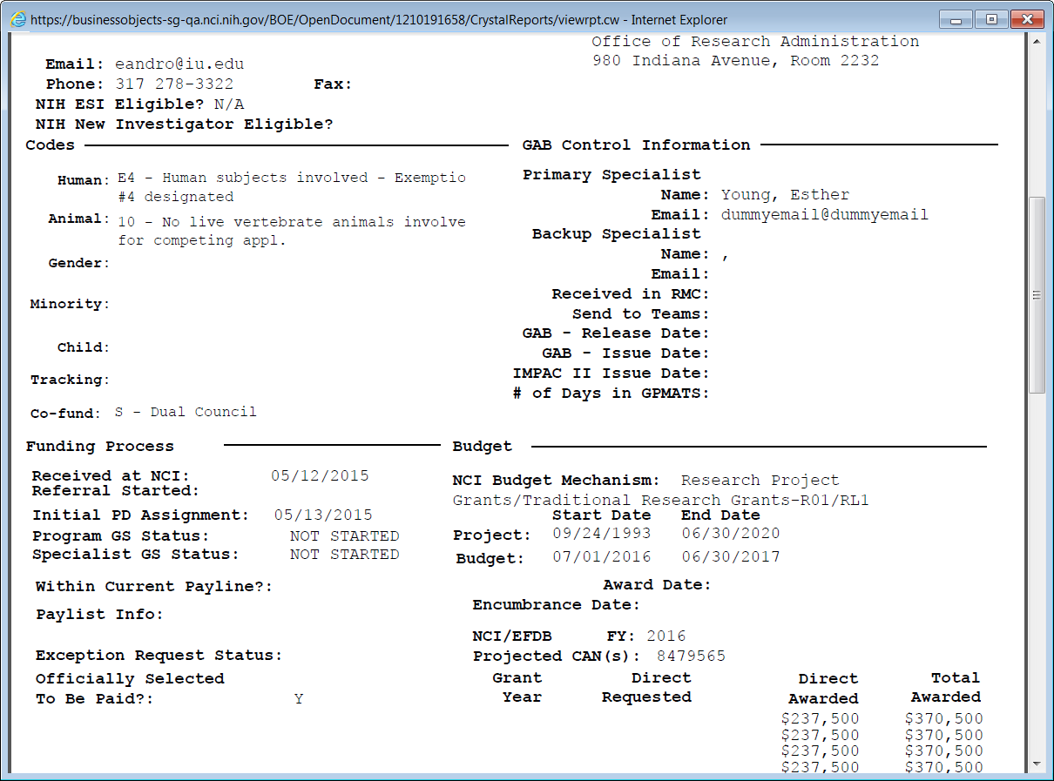

## **Greensheet versioning**

Please use mockups below the table for the discussion

|  |  |  |  |
| --- | --- | --- | --- |
| **#** | **Scenario when new FB module is promoted** | **System behavior when user retrieves greensheet** | **Options** |
| 1 | Greensheet is not started | Latest version of template (latest questions) is displayed | n/a |
| 2 | Greensheet is submitted and/or frozen | Version of template on the moment of submission is displayed. Read-only mode | n/a |
| 3 | Greensheet is saved, but not submitted | The system:   * Displays a message that the template has changed and instructions to a user (according to a selected option) * Displays newly promoted template * Keeps prior version(s) of greensheet with answers and attachments (it will be displayed in read-only mode; version date will be displayed) until the next version is submitted. User can open this version in a separate browser window. * For the next step – see options (OGA needs to select) * After submission of the current version, prior versions will be deleted | Option 1:   * All answers should be re-entered again manually from scratch (no automatic matching) * Provide ability to copy attachments from prior version into ANY question in latest (current) version |
| Option 2:   * Attempt automatic match of the answers (copy from **LATEST** prior version into the current version) and copy attachments. * Provide a warning that matching is approximate and may not be correct. Allow user to edit answers and move attachments around. Provide a message if some answers/attachments don’t match at all. * Still provide ability to copy attachments from prior version into ANY question in latest (current) version |
| 4 | Greensheet is unfrozen after new module is promoted | Same as in scenario “Greensheet is saved, but not submitted” |  |

Figure1: Proposed functionality for OPTION 1

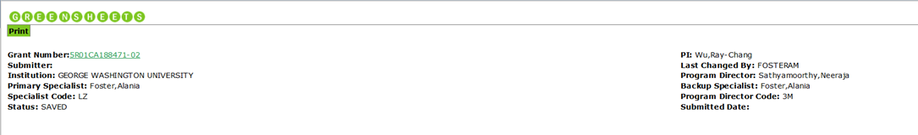

**The greensheet template has been updated in FormBuilder and the questions might have changed. Please re-enter the answers and, if necessary, move attachments into this version.**

**NOTE: after submission of current greensheet, the prior version(s) and all prior attachments will be DELETED.**

To copy attachment from prior version (if exists), click on attachment icon on this screen for a selected question

**View prior version(s):** 06/20/16 04/18/2016

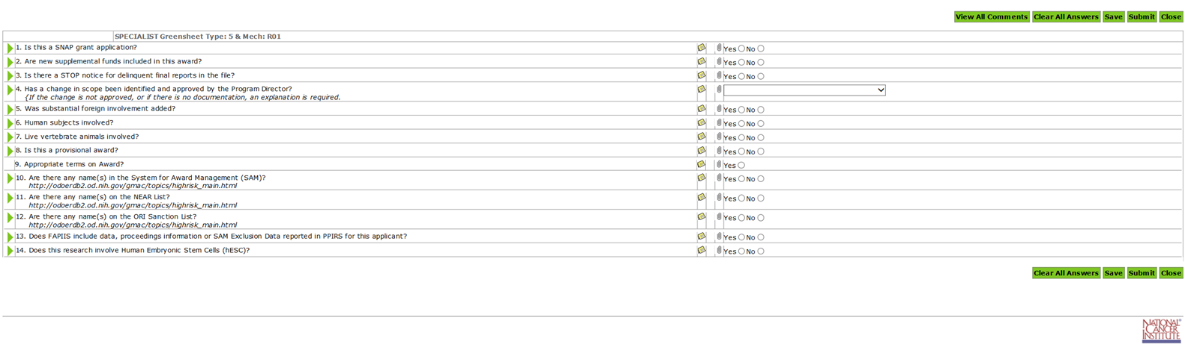

Figure 2: Proposed functionality for Option 2



**The greensheet template has been updated in FormBuilder and the questions might have changed. The system automatically matched the answers and attachments to the questions that did not change (if any). Please check for correctness and enter answers to the updated questions.**

**NOTE: after submission of current greensheet, the prior version(s) and all prior attachments will be DELETED.**

To copy attachment from prior version (if exists), click on attachment icon on this screen for a selected question

**View prior version(s):** 06/20/16 04/18/2016

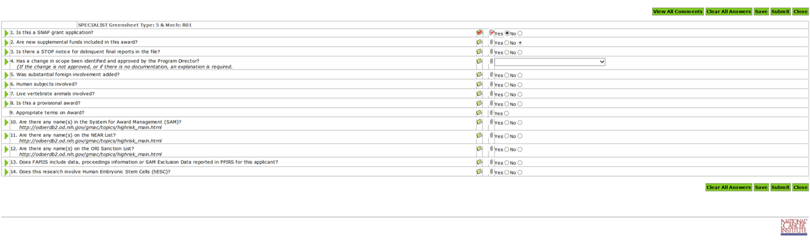

NOTE(s):

1. The system should accommodate multiple prior versions. Theoretically, it is possible that:
   * A new template has been promoted from FB,
   * Users started to work on current version, but did not submit them yet,
   * And a new template has been promoted again.

Even if it might be not probable, but the system should have handle such situation without breaking.

1. The message and “View prior version(s)” label will be displayed only if prior version(s) exist. The dates indicate the date(s) when the form for this template become read-only.
2. The system will have to populate expiration date for all templates where this date is blank when a set gets promoted. It will be easier to query later.

When user selects a prior version (by clicking on a date link), it will be open as read-only in a separate browser window.

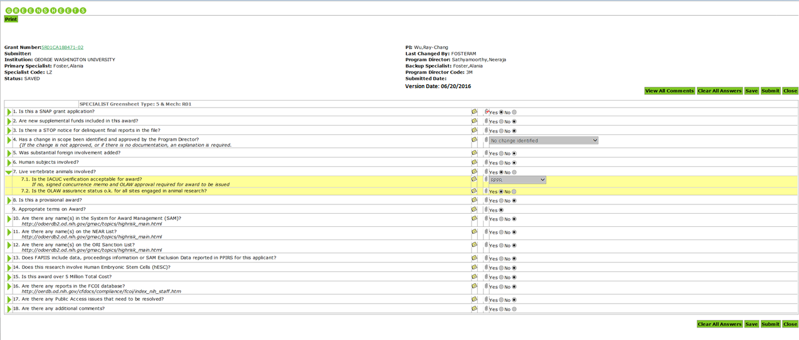

**User flow for Option1:** user will open old version in a separate browser window, and do the following:

* Compare the questions/answers and manually re-enter answers
* Open the comments and manually copy comments into a current version into appropriate question (if needed)
* Attachments (user clicks attachment icon in CURRENT version window for a specific question):
  + Current “Add attachment” functionality will be kept
  + In addition, ability to copy attachments from prior version will be provided. If user clicks “Copy attachments from prior version” button, the system will display the list of questions from prior version that had attachment(s). User can select a question and click Copy. All attachments for selected question will be copied into the question in current version, for which user originally clicked 

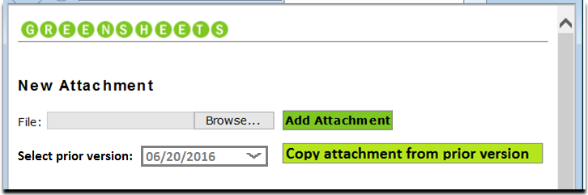

NOTE: Select prior version dropdown and corresponding “Copy..” button will be displayed only if prior version(s) exist. The dates in the dropdown indicate the date(s) when the prior version(s) become read-only.

If user clicks Add Attachment: we will keep existing functionality:

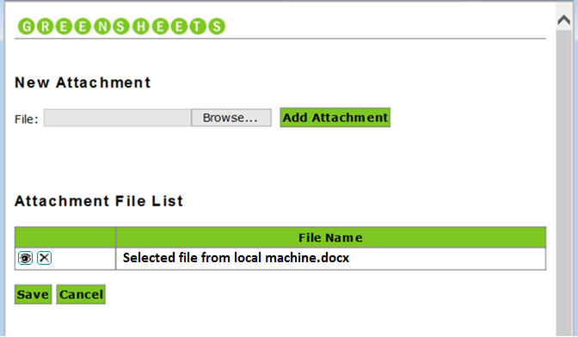

If user clicks “Copy attachment from prior version” button, the list of all questions that have attachments from a selected version will appear.

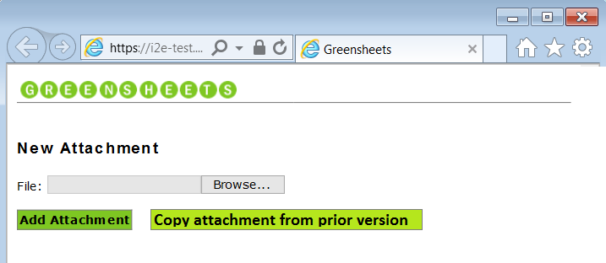

|  |  |  |
| --- | --- | --- |
| **Questions with attachments** | **File Name** | **Action** |
| Is this a SNAP application? | Attachment name 1.docx |  |
| Attachment name 22.docx |
| Is this a provisional award? | Email PDF1.pdf |  |
| Is this award over 5 Million Total Cost? | Doc3333.doc |  |

User will request to copy attachments from a selected question; all attachments will be moved into “**Attachment File List”** section. User can delete or view any attachment. User can add attachments from different question into the selected question for a current version.



|  |  |  |
| --- | --- | --- |
| **Questions with attachments** | **File Name** | **Action** |
| Is this a SNAP application? | Attachment name 1.docx |  |
| Attachment name 22.docx |
| Is this a provisional award? | Email PDF1.pdf |  |
| Is this award over 5 Million Total Cost? | Doc3333.doc |  |

**Attachment File List**

|  |  |
| --- | --- |
|  | **File Name** |
|  | Attachment name 1.docx |
|  | Attachment name 22.docx |
|  | File that user added manually into a current version.doc |



**User flow for Option2:** same as for option 1, except that initially the system will automatically copy answers/comments/attachment from the **LATEST** version (if any). Ability to view all prior versions will still be provided and user can manually copy attachments and from them.